**Experiment 3.1**

**Student Name: Geetanjali UID: 21MCC1013**

**Branch: ME CSE-CC Section/Group: 21MCC-1**

**Semester: 2 Date of Performance: 24-04-2022**

**Subject Name: Cloud Automation and Scripting for System Administrators Lab**

**Subject Code: 21CSH-687: P**

**1. Aim/Overview of the practical:** Create a Repository and make changes like Merge Branches, push changes, commit changes, check status.

**2. Task to be done:**

Show the implementation of below points.

1. Merge Branches
2. Push Changes
3. Commit Changes
4. Check status

**3. Pre Requisites:**

Github account should be created.

**4. Steps for Experiment:**

Sign in to your github account using github.com url. Click n “Create a new repository” button

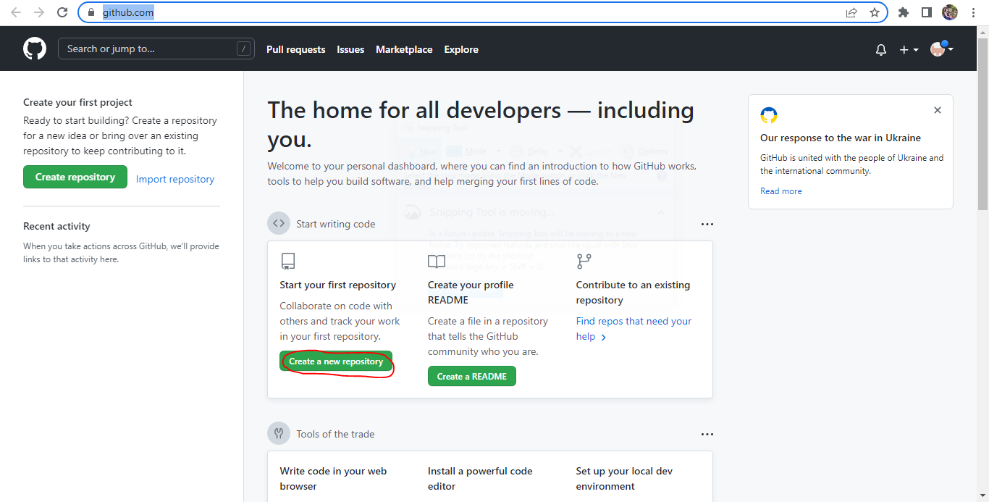

Provide repository name

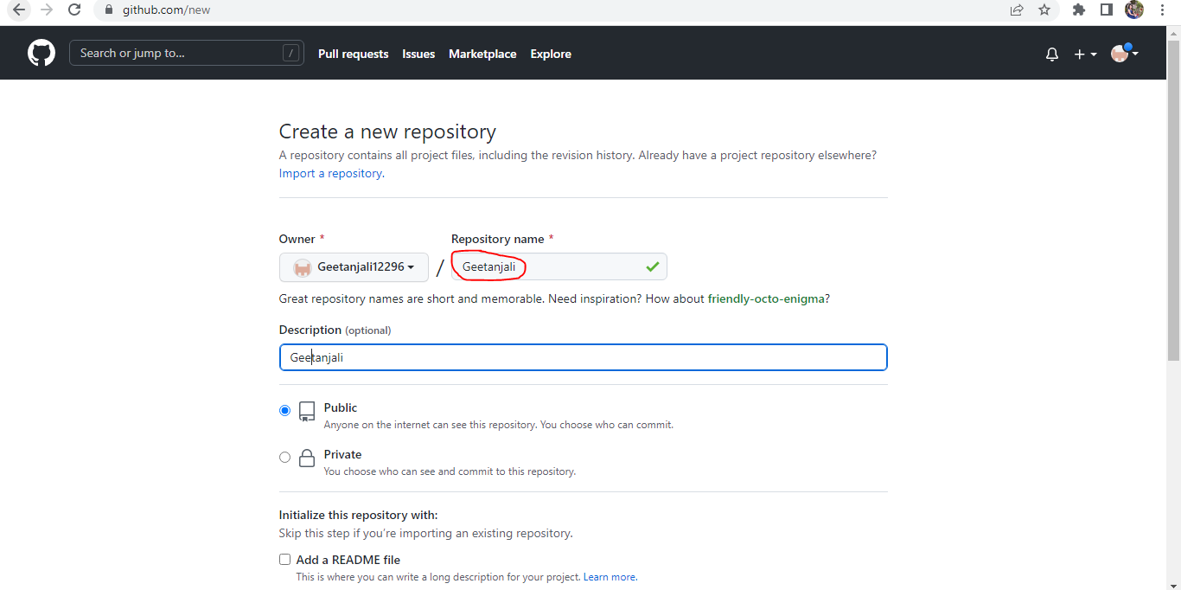

Scroll down and click “Create Repository” button

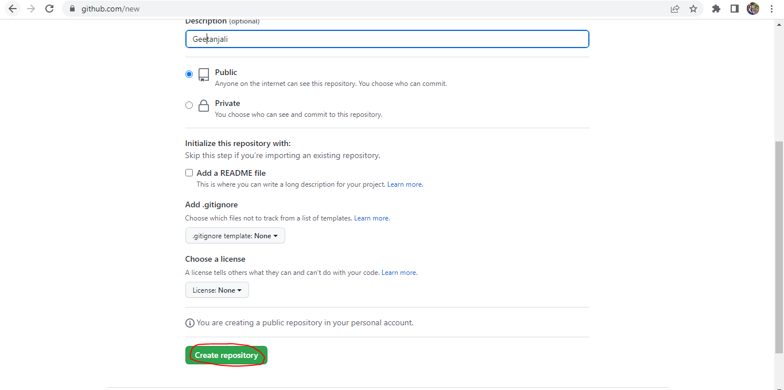

Create a python file in a folder and then right click. Click on “Git Bash here”

Run command “git init”

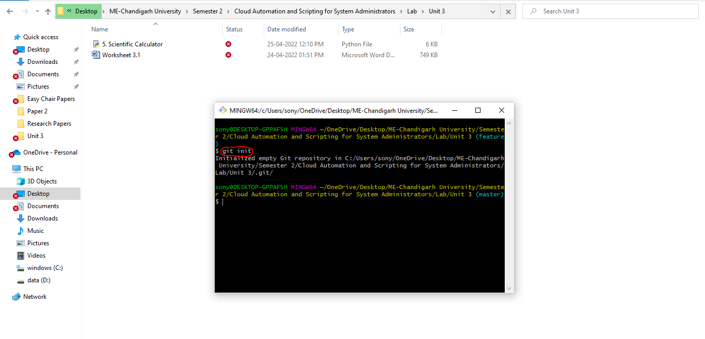

Now, run command “git status”

Now run, git add .

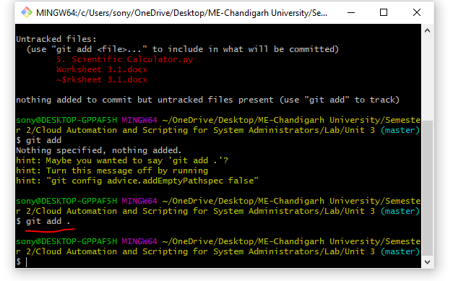

Run command, git status

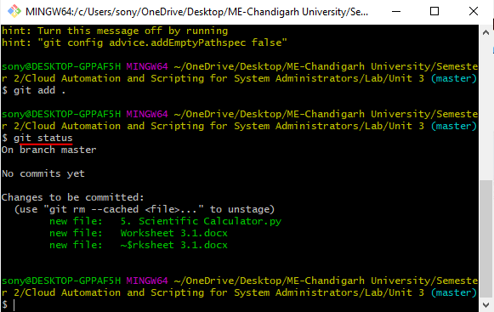

Provide your identity and make first commit

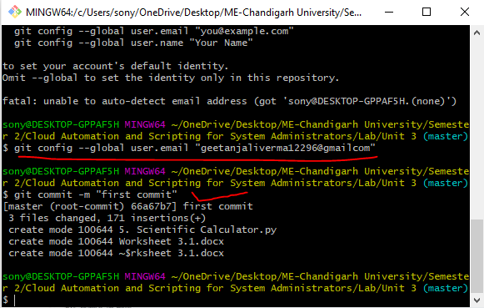

Go back to browser and copy git remote link

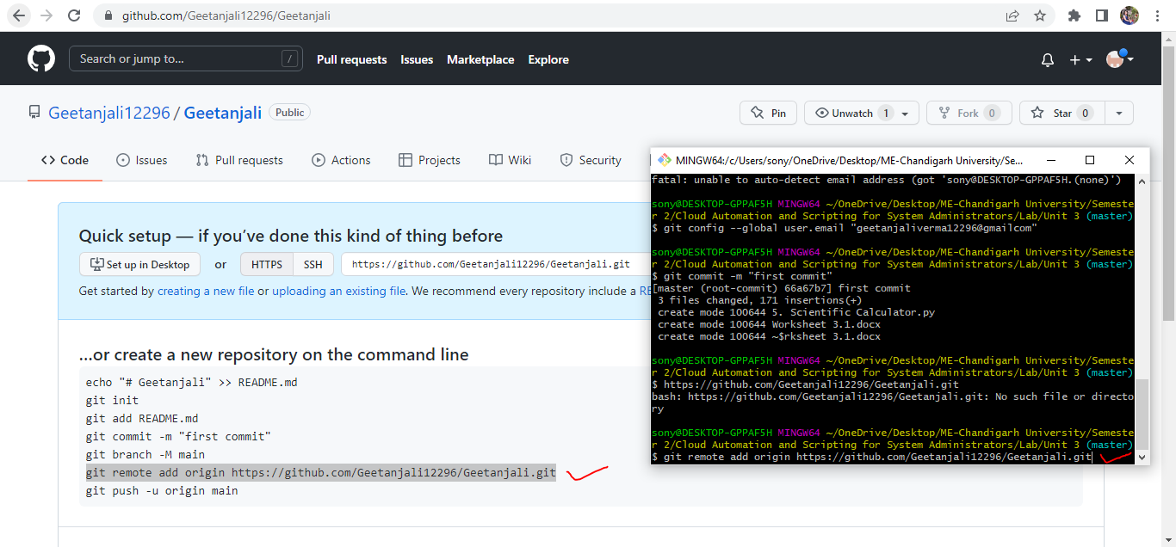

Now run command, git push –u origin master

Sign in page will open

Provide your credentials

**5. Result/Output/Writing Summary:** Casting and conversing of data types, if else statements, case statements using python and ruby languages in Ubuntu

**Learning outcomes (What I have learnt):**

1) Casting and converting (Python vs Ruby)

2) Working with Strings (Python vs Ruby)

3) Working with Numbers (Python vs Ruby)

4) How to take User Input (Python vs Ruby)

5) if-else and switch statements (Python vs Ruby)

**Evaluation Grid (To be created as per the SOP and Assessment guidelines by the faculty):**

|  |  |  |  |
| --- | --- | --- | --- |
| Sr. No. | Parameters | Marks Obtained | Maximum Marks |
| 1. |  |  |  |
| 2. |  |  |  |
| 3. |  |  |  |
|  |  |  |  |